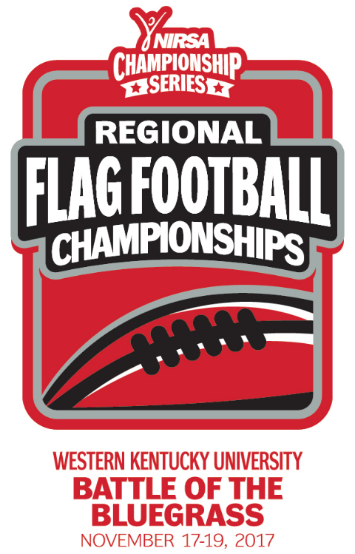
NIRSA Regional Flag
Football Championships
Western Kentucky University
November 17-19, 2017
Bowling Green, KY

2017 TOURNAMENT RESULTS3

Men’s Division
Champion: Western Kentucky University
Runner-up: Alabama A&M University
Championship Final Score: 19-7

Men’s All- Tournament Team
MVP- Grant Rohleder- Western Kentucky University - GOAT
Keldon Washington- Alabama A&M University
Tyler King- Alabama A&M University
Kale Mitchell- Tennessee Technological University
Xjavion Boyd- Lincoln University
Sam Mattingly- Western Kentucky University - GOAT
James McMillen- Western Kentucky University - GOAT

Co-Rec Division
Champion: Mississippi State University
Runner-up: Austin Peay State University
Championship Final Score: 43-0

Co-Rec All-Tournament Team
MVP- Haven Watkins- Austin Peay State University
Jeffery Pate- Mississippi State University
Jasmine Buckhalter- Mississippi State University
Beth Jones- Mississippi State University
Emily Holloway- Austin Peay State University
Justus Gaines- Austin Peay State University

Women’s Division
Champion: Tennessee Technological University
Runner-up: Georgia Southwestern State University
Championship Final Score: 19-6

Women’s All- Tournament Team
MVP- Victoria Permenter- Tennessee Technological University
Sierra Cothran- Tennessee Technological University
Carly Youngblood- Tennessee Technological University
Brittany Farmer- Tennessee Technological University
Brianna Washington- Georgia Southwestern State University
Jatah Spencer- Georgia Southwestern State University
Alysia Oliver- Georgia Southwestern State University

All- Tournament Officials
Nick Calhoun -University of North Georgia
Ian Stonestreet - Mississippi State University
Anna Parks - University of Georgia
Rory Sullivan - University of South Florida

Devron Cheaten- Mississippi State University
Jose Contreras- Mississippi State University

