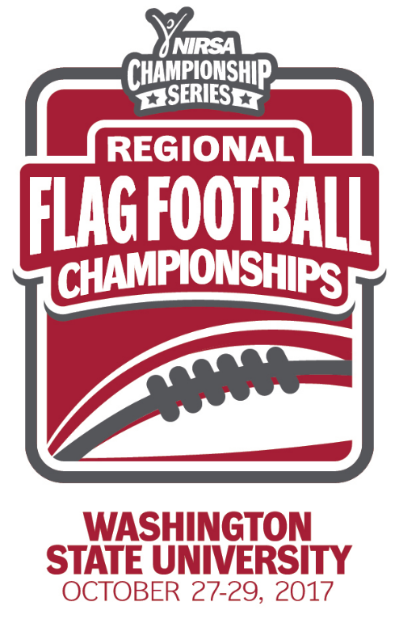
NIRSA Regional Flag
Football Championships
Washington State University
October 27-29, 2017
Pullman, WA

2017 TOURNAMENT RESULTS

Men’s Division
Champion: Western Oregon University - Wolves
Runner-up: Washington State University - Daddy Pierce & The Boys
Championship Final Score: 21- 20

Men’s All- Tournament Team
MVP- Cody Chimienti - Western Oregon University - Wolves
Austin McBryde - Washington State University - Daddy Pierce & The Boys
Eric Flierl - Western Oregon University - Wolves
Mitchell Alberts - Washington State University - Daddy Pierce & The Boys
Cordae Mcafee – Washington State University - The Best of Elite
Garrett Granlund – Central Washington University - Scared Hitless
Ryan Peterson - Washington State University - JFU

All- Tournament Officials
Jeff Hares - Seattle University
Jesse Lin - Oregon State university
Aaron Miyasaki - Washington State University
John Tracy - Washington State University
Kevin Cao – University of California, Riverside

