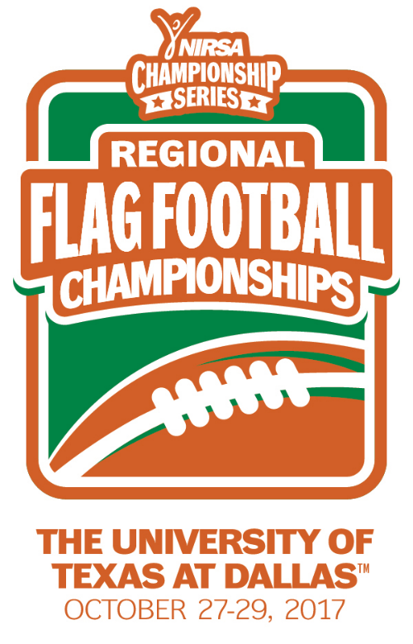
NIRSA Regional Flag
Football Championships
University of Texas at Dallas
October 27-29, 2017
Richardson, TX

2017 TOURNAMENT RESULTS

Men’s Division
Champion: University of Texas at San Antonio - Lightz Out
Runner-up: University of Texas Rio Grande Valley - Scatbacks
Championship Final Score: 34-28

Men’s All- Tournament Team
MVP- Lamar Kimble – University of Texas at San Antonio
Cameron Wilson – University of Texas at San Antonio
Ruben Jimenez – University of Texas at San Antonio
Salvador Martinez – University of Texas Rio Grande Valley
Xavier Suarez – University of Texas Rio Grande Valley
DJ Talamentez – University of Texas Rio Grande Valley
Miguel Castillo - Angelo State University

Women’s Division
Champion: Universidad Autonoma de Nuevo Leon - Tigers
Runner-up: Prairie View A&M University - Savages
Championship Final Score: 21-7

Women’s All- Tournament Team
MVP- Andrea Delgadillo – Universidad Autonoma de Nuevo Leon
Chanel Babineaux- Prairie View A&M University
Samantha Ramos- Universidad Autonoma de Nuevo Leon
Ravyn Gilbert- Prairie View A&M University
Domonique Vela- Texas State University
Stefani Richardson- Angelo State University
Jacie Klose- Angelo State University

Co-Rec Division
Champion: Angelo State University- IM Legends
Runner-up: University of North Texas - FSA
Championship Final Score: 30-23

Co-Rec All-Tournament Team
MVP- Jacie Klose - Angelo State University
Chase Churchwell - Angelo State University
Tien Phan – The University of Texas at Dallas
Louisa Xie - The University of Texas at Dallas
Charles Venters – University of North Texas
Christie Tran – University of North Texas
TJ Brown - Angelo State University
Lindsay Englehart - Angelo State University

All- Tournament Officials
Josh Hale - Angelo State university
Dustin Sturdivant – Stephen F. Austin State University
Brandon Bermea - Texas A&M University
Anthony Villasana – Texas A&M University -Kingsville

