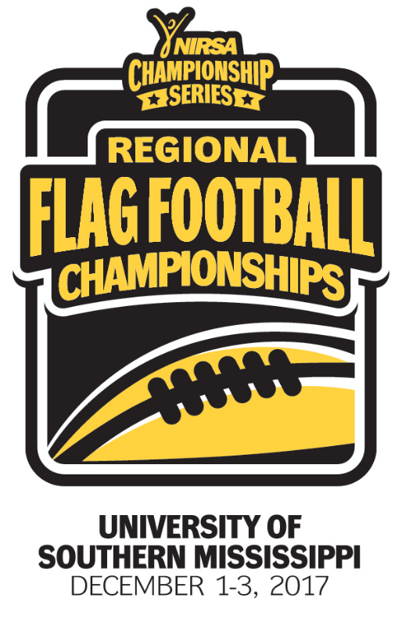
NIRSA Regional Flag
Football Championships
University of Southern Mississippi
December 1-3, 2017
Hattiesburg, MS

2017 TOURNAMENT RESULTS

Men’s Division
Champion: Texas Southern University
Runner-up: The University of Southern Mississippi
Championship Final Score: 35-21

Men’s All- Tournament Team
MVP- Robell Tocruray – Texas Southern University
Jonte Whiting – The University of Southern Mississippi
Burren Edwards – Texas Southern University
Eric Williams – Texas Southern University Dewayne Washington – Texas Southern University
Brady McBride – Florida State University
Derrion Alexander – Stephen F. Austin State University

Women’s Division
Champion: University of Florida
Runner-up: Florida A&M University
Championship Final Score: 7-6

Women’s All- Tournament Team
MVP- Olivia Salzemen – University of Florida
Deliah Autry – Florida A&M University
Amanda Chromiak – University of Florida
Jayci Grosso – University of Florida
Adrianna Harvey – Florida A&M University
Aaliyah Barrington – Florida A&M University
Meghan Knight – Northwestern State University

Co-Rec Division
Champion: Northwestern State University
Runner-up: Louisiana Tech University
Championship Final Score: 32- 21

Co-Rec All-Tournament Team
MVP- Savonya Robinson – Northwestern State University
Cody Wagner – Northwestern State University
Devin Mitchell – Louisiana Tech University
Robert Ritchey – Louisiana Tech University
Meghan Knight – Northwestern State University
McKinley Green – Northwestern State University
Ashley Coberly – University of West Florida
Derrion Alexander – Stephen F. Austin State University

All- Tournament Officials
Nicholas Calhoun – University of North Georgia
Dustin Sturdivant – Stephen F. Austin State University
Stephanie Calhoun – Indiana University
Josh Brown – Georgia College & State University
Christian Bettencourt - Florida Atlantic University

