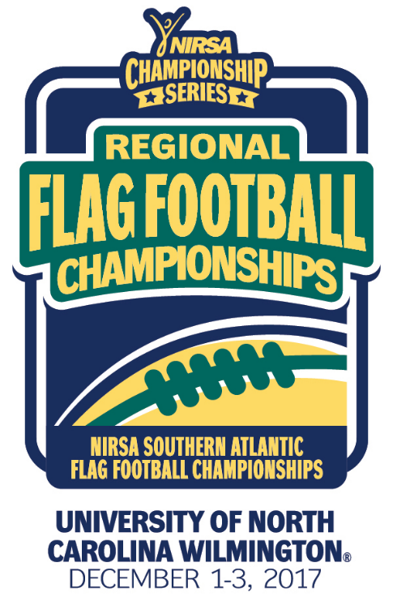
NIRSA Regional Flag
Football Championships
University of North Carolina- Wilmington
December 1-3, 2017
Wilmington, NC

2017 TOURNAMENT RESULTS

Men’s Division
Champion: North Carolina A&T
Runner-up: East Carolina University
Championship Final Score: 25-0
Men’s All- Tournament Team
MVP-Kevin Caldwell - North Carolina A&T
Leon Jensen - Marine Corps Air Station, New River
Kelvin Brimm - University of North Carolina, Pembroke- Untouchables
Vernell Mackey - North Carolina A&T
Julien Stephen - North Carolina A&T
Cole Woodard - East Carolina University
Josh Smith - East Carolina University
Co-Rec Division
Champion: University of North Carolina, Pembroke
Runner-up: High Point University
Championship Final Score: 26-23
Co-Rec All-Tournament Team
MVP- Myicha Drakeford - University of North Carolina, Pembroke
Ben Lodewyk - High Point University
Brittany Taylor - Fayetteville State University
Matt Twigger - University of North Carolina, Wilmington
Tori Farlow - University of North Carolina, Wilmington
Bryant Reed - University of North Carolina, Pembroke
Jade Jones - University of North Carolina, Pembroke
Aleah Wendels - High Point University
All- Tournament Officials
Alex Dixon - University of Maryland College Park
Wyatt Howard - North Carolina State University
Reese Walton - University of North Carolina, Wilmington
Brandon Miller - Georgia Southern University
Jordan Cox - Kennesaw State University
Courtney Chmielewski - Virginia Tech

