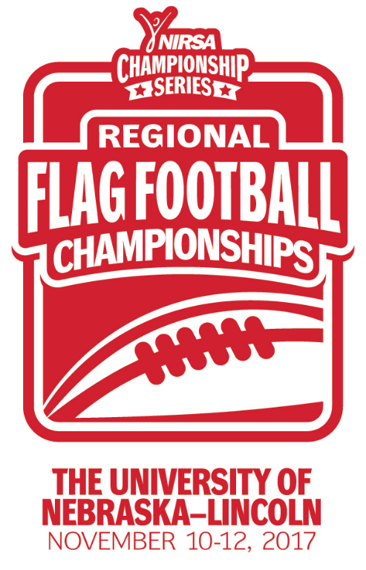
NIRSA Regional Flag
Football Championships
University of Nebraska- Lincoln
November 10-12, 2017
Lincoln, NE

2017 TOURNAMENT RESULTS

Men’s Division
Champion: Wayne State College
Runner-up: University of Nebraska-Lincoln
Championship Final Score: 18-13

Men’s All- Tournament Team
MVP- Casey Wisnieski - Wayne State College
Chevy Henneman - University of Nebraska
Destry Beeck - Wayne State College
Ben Kuehn - Wayne State College
Yahya Sheikhaden - University of Missouri Kansas City
Bryce Ewing - University of Nebraska

Women’s Division
Champion: University of Nebraska
Runner-up: Central Methodist University
Championship Final Score: 18-14

Women’s All- Tournament Team
MVP- Brook McCluskey - University of Nebraska
Kelsey Kenecht - University of Nebraska
Michele Rupard - Central Methodist University
Hannah Iborg - Central Methodist University
Stephanie Lietenacker - Emporia State University
Alex Klema - Emporia State University

Co-Rec Division
Champion: University of Nebraska
Runner-up: Colorado State University-Pueblo
Championship Final Score: 36-9

Co-Rec All-Tournament Team
MVP- Greg Shafe - University of Nebraska
Brook McCluskey - University of Nebraska
Kelsey Knecht - University of Nebraska
Anh Nguyen - University of Nebraska
Tyler Long - Colorado State University-Pueblo
Brittnee Cobery - Colorado State University-Pueblo

All- Tournament Officials
Joseph Scott - Creighton University
Matthew Eastmo - Creighton University
Julianna Johnson - University of Maryland
Logan Lewis - University of Nebraska

