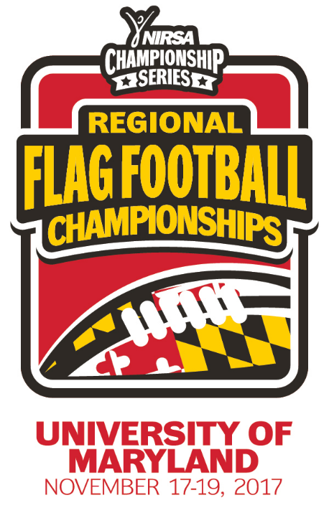
NIRSA Regional Flag
Football Championships
University of Maryland
November 17-19, 2017
College Park, MD

2017 TOURNAMENT RESULTS

Men’s Division
Champion: North Carolina A&T University
Runner-up: University of Maryland - Baltimore
Championship Final Score: 37-0

Men’s All- Tournament Team
MVP- Vernell Mackey - North Carolina A&T University
Sean Young – University of Maryland - Baltimore
Kevin Caldwell - North Carolina A&T University
Joshua Keku - North Carolina A&T University
Aaron Tadayon – University of Maryland - Baltimore
Michael Shepherd – Delaware State University

Women’s Division
Champion: North Carolina A&T University
Runner-up: Delaware State University
Championship Final Score: 26-19

Women’s All- Tournament Team
Co-Rec Division
Champion: Stockton University
Runner-up: Towson University
Championship Final Score: 34-10

Co-Rec All-Tournament Team
MVP- EJ Wallace – Towson University
Isabella de Diego – Stockton University
Rachael Fordham – Stockton University
Ryan Tiefenbucher – Stockton University
Cam Cunningham – Towson University
Claire Milton – Delaware State University

All- Tournament Officials
Julie Johnson – University of Minnesota Duluth
Dylan Steinkruger – University of Nebraska-Lincoln
Montrell Cade – George Southern University
Savon Williams – University of San Francisco
Mia Stewart – Cornell University

MVP- LaQuana Horge – North Carolina A&T University
Mariah Washington – North Carolina A&T University
Diamond Lu – Delaware State University
Michaela Morph – Delaware State University
Tiyanna Stewart – Howard University
Veronica Cervelli – Monmouth University

