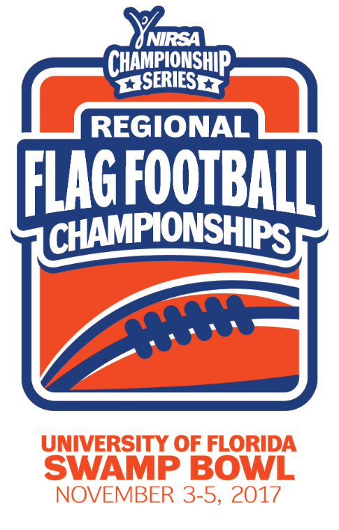
NIRSA Regional Flag
Football Championships
University of Florida
November 3-5, 2017
Gainesville, FL

2017 TOURNAMENT RESULTS

Men’s Division
Champion: University of Florida
Runner-up: Naval Air Station- Jacksonville
Championship Final Score: 26-20

Men’s All- Tournament Team
MVP-Christian Martinez - University of Florida
Gioberti Derogen - University of South Florida
Fernando Rodriguez - University of Florida
Robert Segerra - Naval Air Station- Jacksonville
Jacob Garza - Naval Air Station- Jacksonville
Mike Johnson - Naval Air Station- Jacksonville
Eric Futch - University of Florida

Women’s Division
Champion: University of Florida
Runner- Up: Florida A&M University
Championship Final Score: 18-12

Women’s All- Tournament Team
MVP - Olivia Salzman - University of Florida
Deliah Autrey - Florida A&M University
Christina Mattis - Florida A&M University
Valerie Perez - Florida A&M University
Brittany Jabot - University of Florida
Amanda Chromiak - University of Florida
La'Quana Hordge – North Carolina A&T State University

Co-Rec Division
Champion: Valdosta State University
Runner-up: University of South Florida
Championship Final Score: 53-0

Co-Rec All-Tournament Team
MVP- Wes Carter - Valdosta State University
Courtney Carter - Valdosta State University
Theseus Jackson - Valdosta State University
Jake Parker - Valdosta State University
Giselle Cardel - University of South Florida
Nick Gimbrone - University of South Florida
Dylan Angelo - University of Florida
Courtney Taylor - Valdosta State University

All- Tournament Officials
Josh Brown - Georgia College
Bart Belderbos -University of Central Florida
Nuri Troy - University of Central Florida
Grant Gallup - University of Florida

