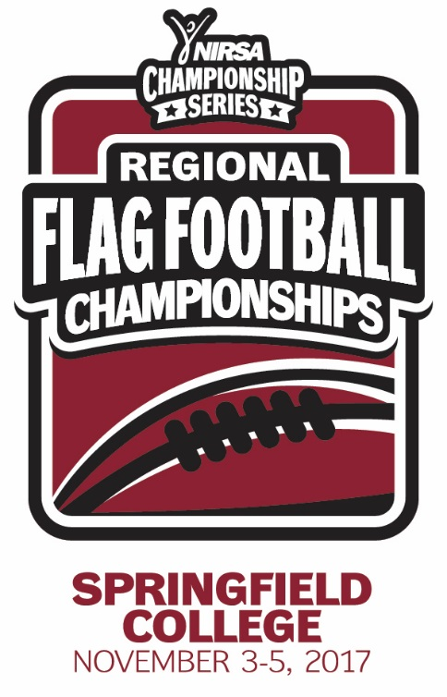
NIRSA Regional Flag
Football Championships
Springfield College
November 3-5, 2017
Springfield, MA

2017 TOURNAMENT RESULTS

Men’s Division
Champion: Rutgers University
Runner-up: Bloomsburg University
Championship Final Score: 21-20

Men’s All- Tournament Team
MVP- Eric Jankowitz – Rutgers University
John Hassert – Rutgers University
Michael Constantino – Southern New Hampshire University
Josh Hirschfeld – Southern New Hampshire University
Chris Gallaher – Bloomsburg University
EJ Wallace – Towson University
Cam Cunningham – Towson University

All- Tournament Officials
Drew Metrey – University of Maryland
Mia Stewart – Cornell University
Mike Villano – Boston College
Dylan Hill – University Brockport

