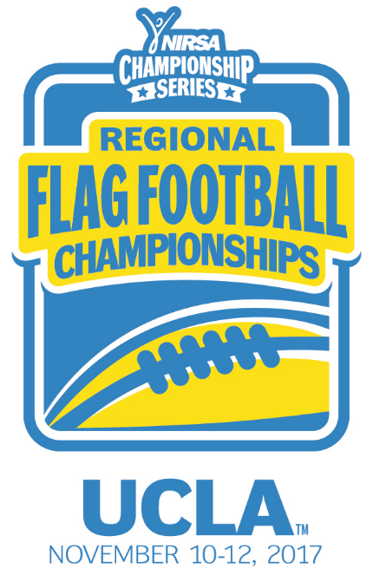
NIRSA Regional Flag
Football Championships
UCLA
November 10-12, 2017
Los Angeles, CA

2017 TOURNAMENT RESULTS

Men’s Division
Champion: Dixie State University – Juice Boxes
Runner-up: Grand Canyon University – Lopes
Championship Final Score: 33-12
Men’s All- Tournament Team
MVP-Ryan Collins – Dixie State University
Brock Anderson – Dixie State University
Carson Hantula – Grand Canyon University
Herb Tiffany – Northern Arizona University
Stephan Ostrowski – Loyola Marymount University
Co-Rec Division
Champion: Arizona State University – Aardvarks
Runner-up: Dixie State University – Trailblazers
Championship Final Score: 16-12
Co-Rec All-Tournament Team
MVP- Allison Weller – Arizona State University
Brennan Rivera – Arizona State University
Tracey Strong – Dixie State University
Keani Napuunoa – University of Nevada, Las Vegas
Tammy Stewart – Cal Poly Pomona
All- Tournament Officials
Emil Shallon – UCLA
Dominique McDonald – UCLA
Matt Goldstein – Arizona State University
Gabe Klein – University of Arizona
Riley Cohn – Arizona State University

